**17 Stochastic models of outbreaks**

**Overview**

**PART I: DTMC model**

Plot sample paths and (quasi-stationary) probability distribution in the following cases:

1. DTMC SIS model

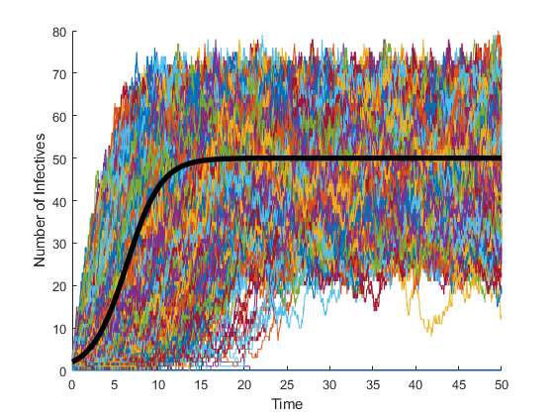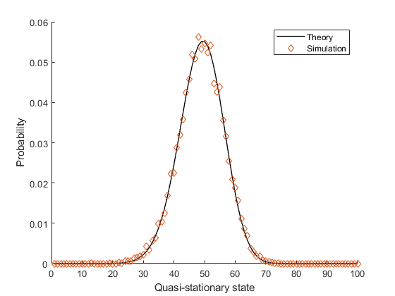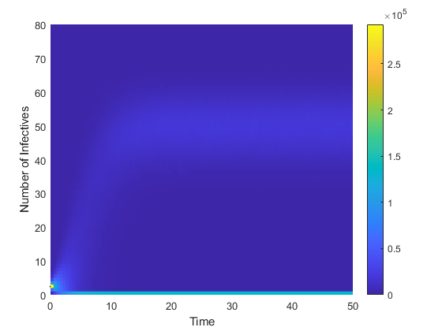

1. DTMC SIS model

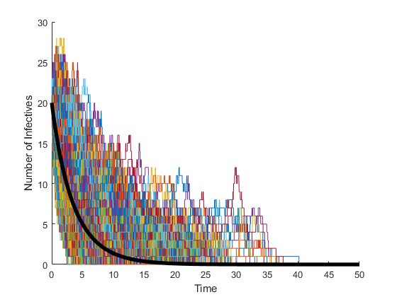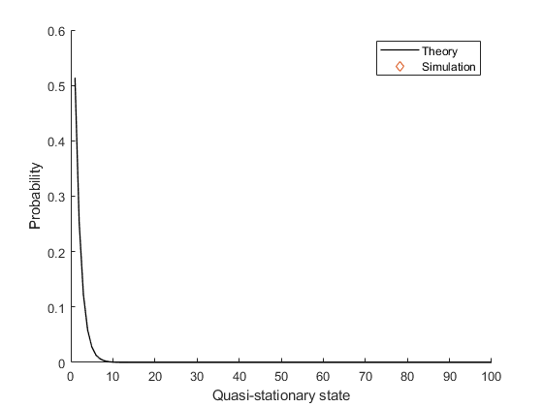

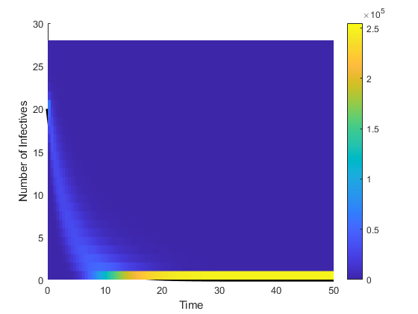

The can be calculated as . The of number 1 parameter set is 2 but the one from parameter set at the problem 2 is just 0.5. Therefore, the difference in the density function of quasi-stationary states occurs.

1. DTMC SIR model

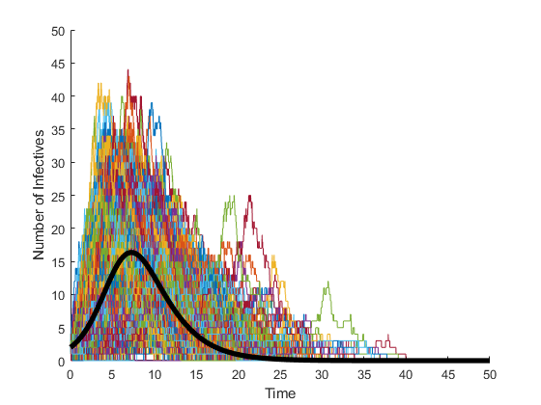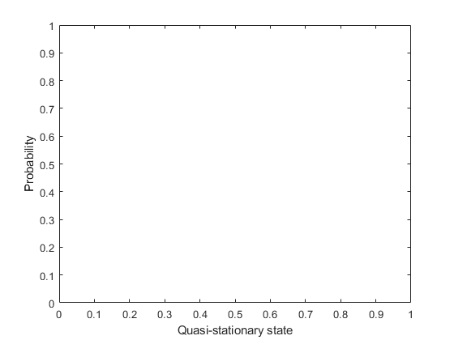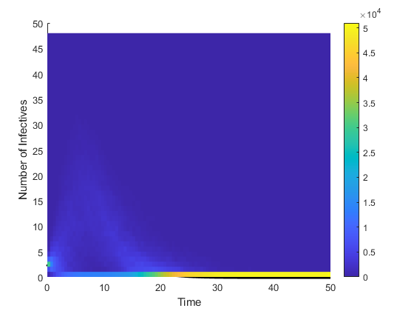

1. DTMC SIR model

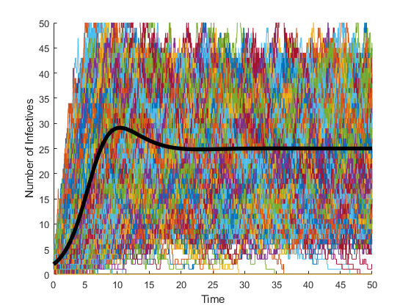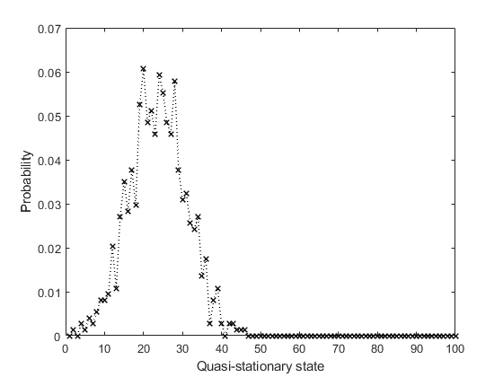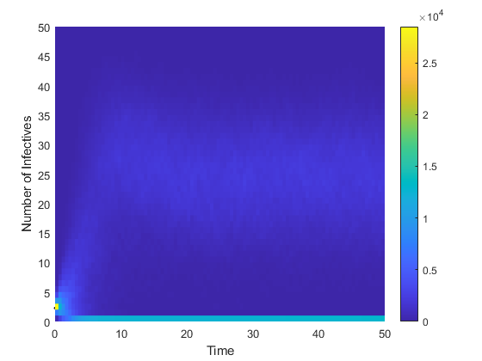

**PART II: CTMC model**

Plot sample paths and (quasi-stationary) probability distribution:

1. CTMC SIS model

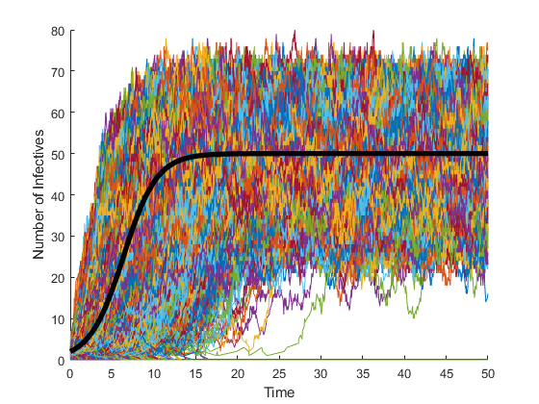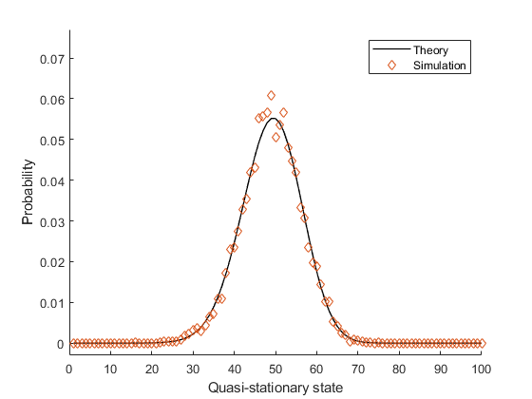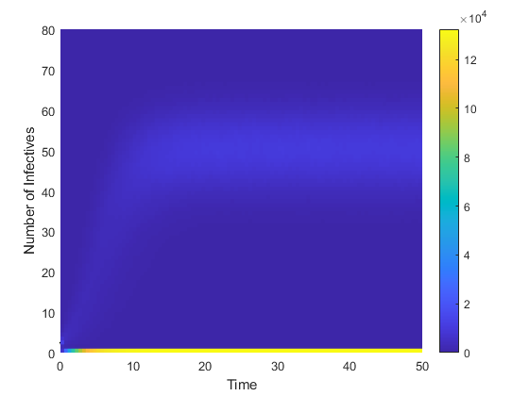

1. CTMC SIS model

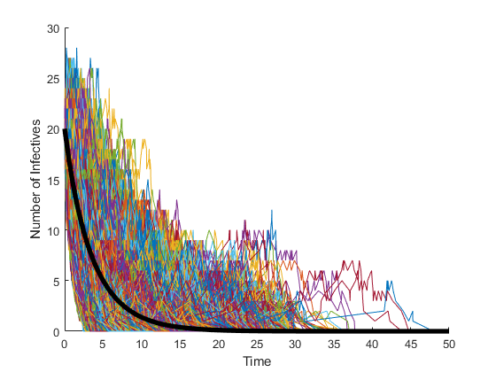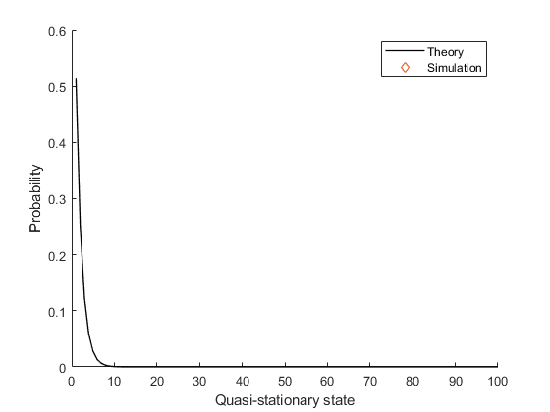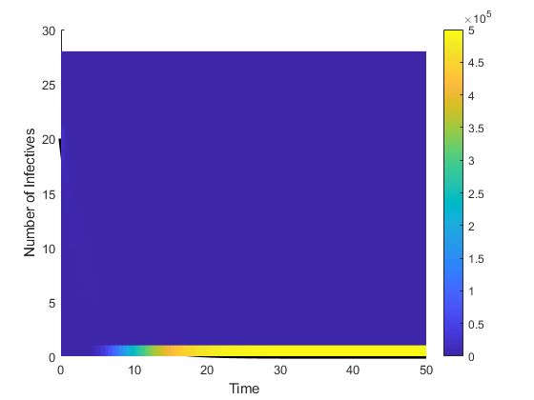

1. CTMC SIR model .

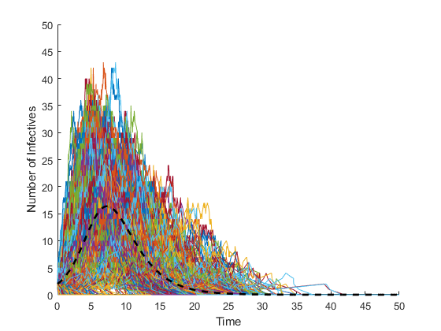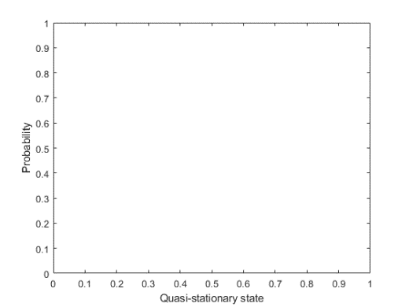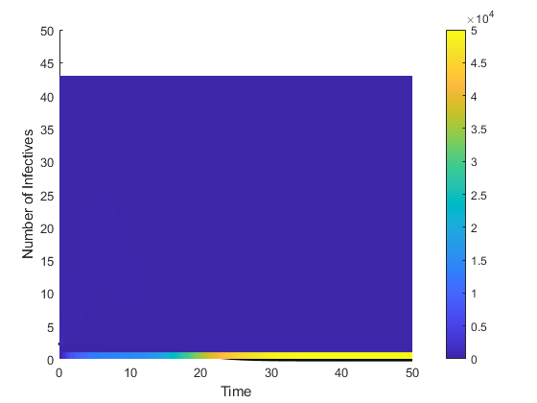

1. CTMC SIR model

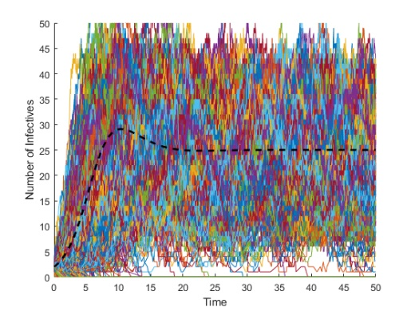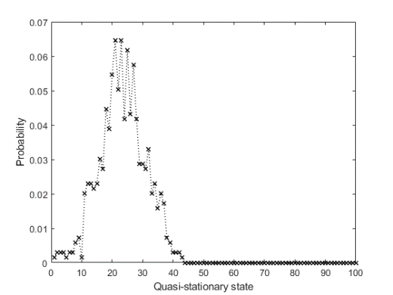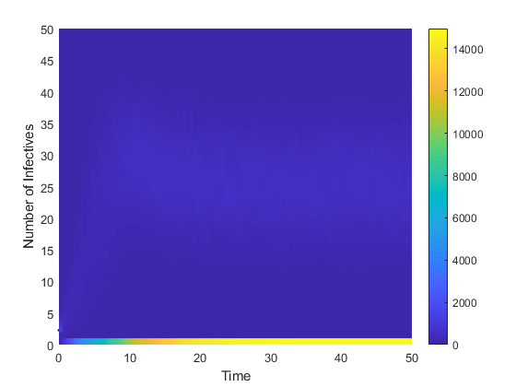

1. Plot the graph of the probability of an outbreak as a function of time for different initial infectives . Use the same values for other parameters as in Q4. Compare the results with the formula.

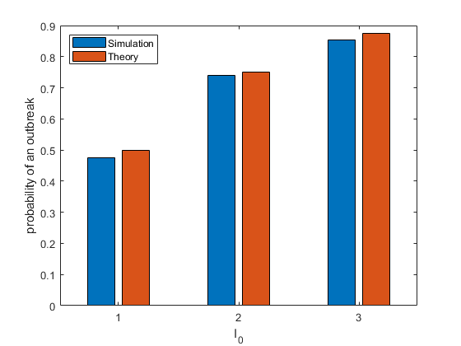

Numerical: 0.4970, 0.7220, 0.8590

Theoretical: 0.5000, 0.7500, 0.8750

1. Repeat the Q5 for different values of by varying the values of .

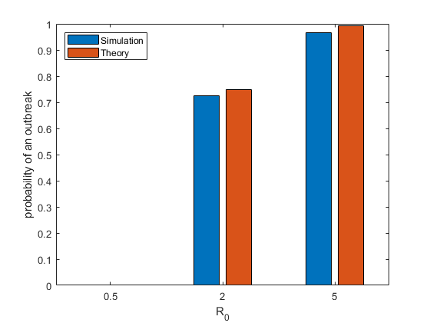

Numerical: 0.0000, 0.7250, 0.9480 ()

Theoretical: 0.0000, 0.7500, 0.9600 ()

1. Run the CTMC SIR model with to plot the graph of final size distribution for different values of .

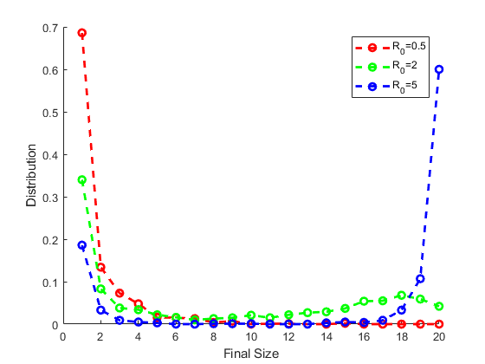

**PART Ⅲ: SDE model**

Plot sample paths and (quasi-stationary) probability distribution in the following cases:

1. SDE SIS model

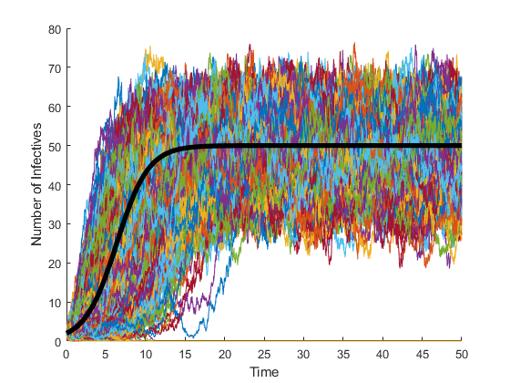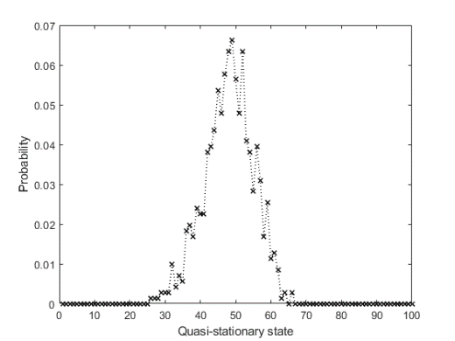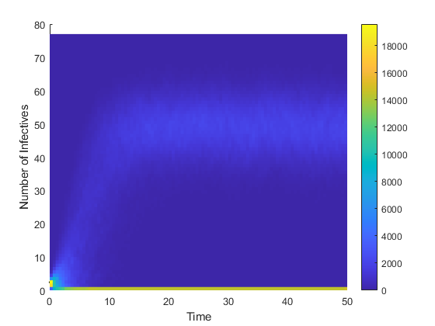

1. SDE SIS model

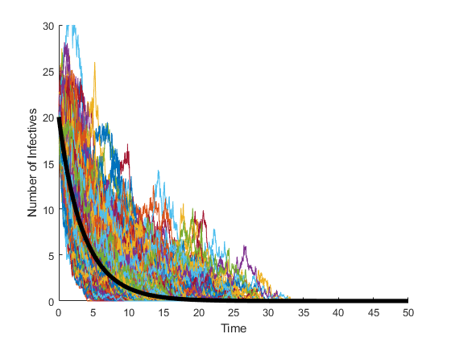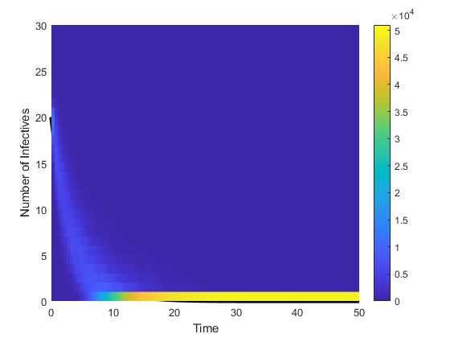

1. SDE SIR model

